Term Project 3차

2017112524 오희경

1. 테이블 생성(밑줄 : primary key / 빨간 글씨 : foreign key)

팀(이름, 년, 월, 일)

create table team(

-> name varchar(10) not null,

-> year int not null,

-> primary key (name));

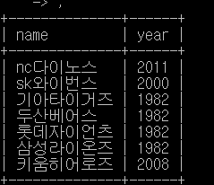

선수(등번호, 이름, 선배 등번호, 이름(팀), 계약일)

create table player(

-> id int not null,

-> name varchar(10) not null,

-> elderid int,

-> t_name varchar(10),

-> primary key(id),

-> foreign key(t_name) references team(name)

-> );

alter table player

-> add constraint foreign key (elderid) references player(id);

alter table player

-> add (contract int);

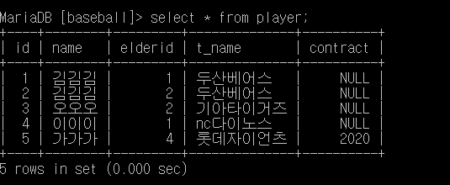

선수-포지션(등번호, 포지션)

create table player_position(

-> id int not null,

-> position varchar(10) not null,

-> primary key (id, position),

-> foreign key (id) references player(id)

-> );

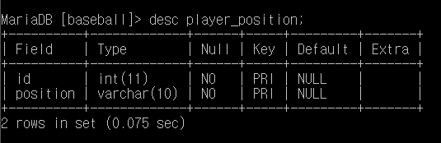

경기장(이름, 수용 관객수, 도, 시, 도로명)

create table stadium(

-> name varchar(10) not null,

-> num_audience int,

-> state varchar(10),

-> city varchar(10) not null,

-> road varchar(10) not null,

-> primary key (name)

-> );

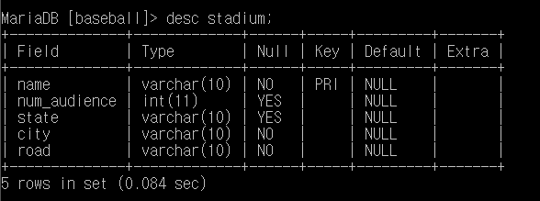

경기장-전화번호(이름, 전화번호)

create table sta_tel(

-> name varchar(10) not null,

-> tel varchar(15) not null,

-> primary key (name, tel),

-> foreign key name references stadium(name)

-> );

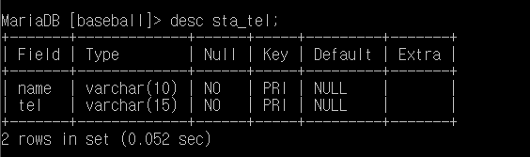

심판(번호, 이름)

create table referee (

-> id int not null,

-> name varchar(10) not null,

-> primary key (id)

-> );

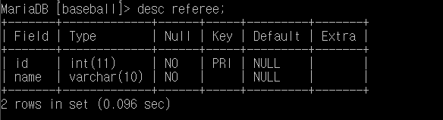

일정(회차, 날짜, 시간) – 강한 개체

create table calendar(

-> round int not null,

-> date date not null,

-> time time not null,

-> primary key (round)

-> );

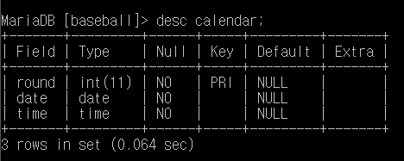

관람객(회원번호, 이름, 년, 월, 일)

create table audience (

-> id varchar(10) not null,

-> name varchar(5) not null,

-> birth_year int,

-> birth_month int,

-> birth_day int

-> primary key (id)

-> );

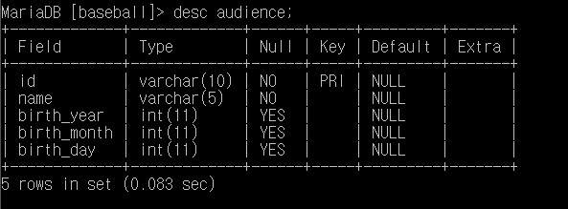

좌석(회차 ,좌석번호) – 약한 개체’

create table seat(

-> round int not null,

-> seat_num varchar(10) not null,

-> primary key (round, seat_num),

-> foreign key(round) references calendar(round)

-> );

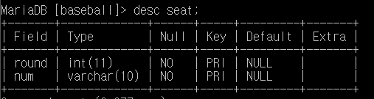

예매(회원번호, 회차, 좌석번호 결제방식, 가격, 할인율)

create table reserve(

-> aud_id varchar(10) not null,

-> seat_round int not null,

-> seat_num varchar(10) not null,

-> primary key (aud_id, seat_round, seat_num),

-> constraint fk1 foreign key(aud_id) references audience(id),

-> constraint fk2 foreign key(seat_round, seat_num) references seat(round, num)

-> );

alter table reserve add payment varchar(10);

alter table reserve add price int;

alter table reserve add sale int;

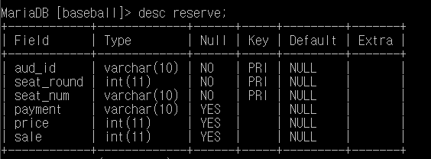

Insert 예시

